César Chávez Academy

Mission Statement

To provide a safe atmosphere of academic excellence that promotes thinkers and problem solvers who work cooperatively and respectfully in an inclusive environment.

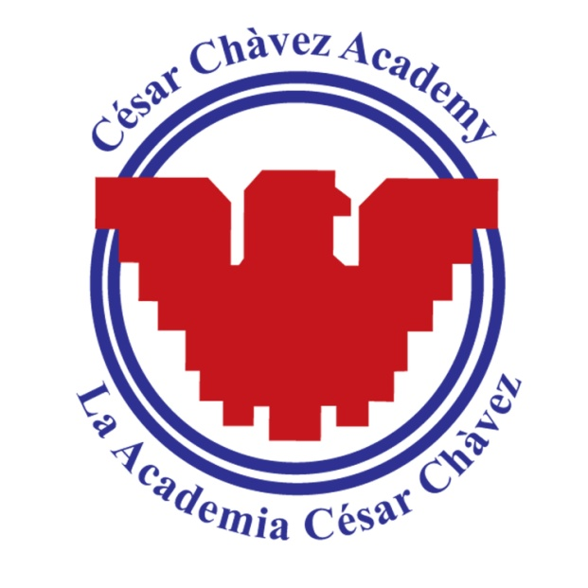

Vision Statement

For all students to be college or career ready and positive,
productive members in a global society.
The statement supports our foundation, “Si Se Puede – Yes We Can”, which reflects the belief that every student is capable of greatness.

